**Here is the java code to return all elements of the array separated by separator:**

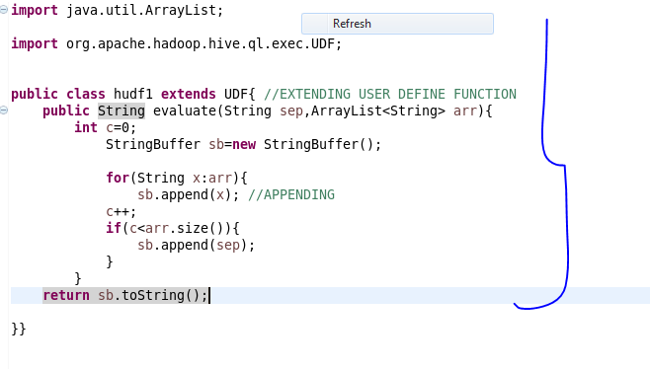

**Here, adding the jar file:**

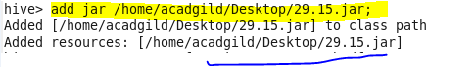

**Creating a table so as to perform operations using user define function and inserting data into it:**

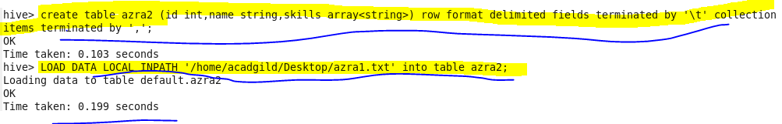

**Creating temporary function ‘conc5’ :**

C:\Users\612926\Desktop\4.png

**Performing basic select operation:**

**Describe table we created for the given problem using desc and then using select all we can show the data in our table:**

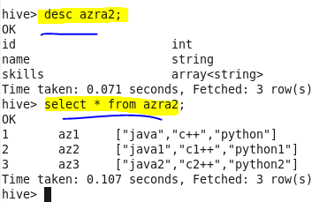

**Retrieving data using temporary function we created:**

